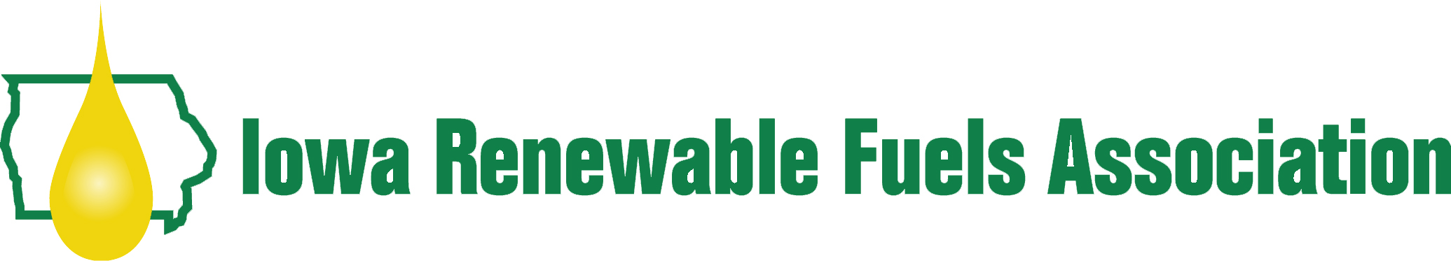
Newsletter Article

Join the Iowa Renewable Fuels Association (IRFA) at the 8th Annual Iowa Renewable Fuels Summit and Trade Show! The Summit is free, open to the public, and will be held January 28, 2014 at The Meadows Conference Center at Prairie Meadows in Altoona, Iowa.

“The Renewable Fuels Summit is Iowa’s premier renewable fuels event bringing together industry leaders, decision makers and the general public to shape Iowa’s energy future,” stated IRFA Managing Director Lucy Norton. “This event provides a great opportunity to hear experts address state and national issues facing the future of renewable fuels, as well as network with biofuels professionals and business leaders throughout the Midwest.”

The debate over renewable fuels policy and biofuels market opportunities is at a fever pitch. That’s why you won’t want to miss the 2014 Summit where presenters will tackle many of these topics, such as the Renewable Fuel Standard, the unique emergence of cellulosic ethanol, the challenges of introducing higher blends of ethanol and biodiesel and where they fit with engines of the future.
To learn more about the 2014 Summit and to register, please visit: www.IowaRFA.org/2014Summit.php

